THE LONGBRANCH FOUNDATION
RECEIVES GIFT from CAROLYN WILEY
Carolyn Wiley’s Farm Tour Quilt
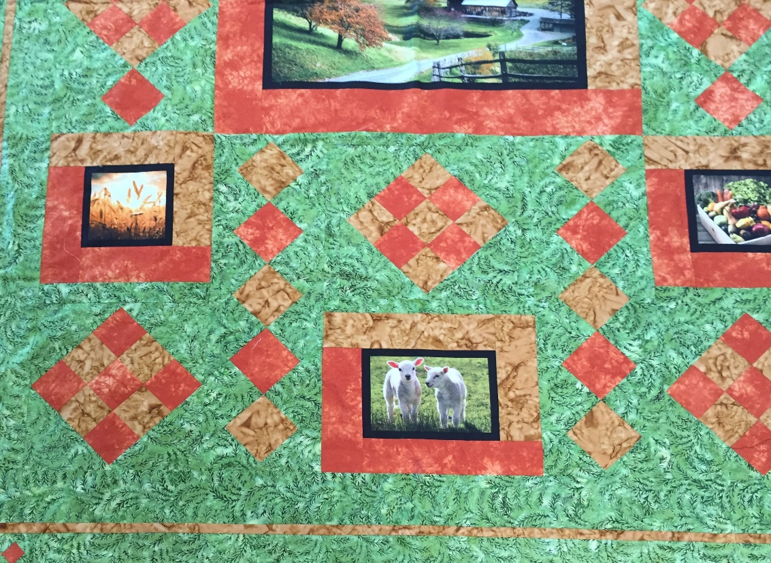
Carolyn Wiley created the Quilt to honor the Farm Tour and gifted the proceeds from the Raffle ticket sales to The Longbranch Foundation.
John Nichols won the Raffle and is pictured with Carolyn Wiley
